INSTRUCTION MANUAL
LCD large screen ozone gas sensor
RS485/Ethernet/WiFi/GPRS/4G/NBIoT
VER1.0

WeihaiJXCTElectronicTechnologyCo.,Ltd.

Ⅰ Brief Introduction
1.1 Product Overview
This series of products are industrial grade sensors with large screen LCD, the products adopt the latest embedded design principle, equipped with 2.88 inch LCD screen, the products are divided into RS485/Ethernet/WiFi/GPRS/4G/NB-IoT.
The Ethernet/WiFi/GPRS/4G/NB-IoT communication sensor adopts the active timing upload mode ，compared with the traditional sensor,theEthernet/WiFi/GPRS/4G/NB-IoT transmitter can realize the sensing Communication is two in one.
At the same time, the equipment can monitor ozone data in real time and use wireless network for transmission. This product network transmission adopts the stable reliable operator network, the technology mature transmission is stable, the signal is strong and the coverage is wide. At the same time, the equipment supports timing data acquisition and actively upload the server platform.
1.2 Sensor Parameters
1.2.1 Probe parameters
Parameter | Qualification
MEASUREMENT RANGE | 0~10ppm
MEASUREMENT RESOLUTION | 0.2 ppm (default probe)
MEASUREMENT METHOD | Electrochemical sensors
RESPONSE TIME | ＜15s
WORKING TEMPERATURE ENVIRONMENT | -30~50℃
WORKING HUMIDITY ENVIRONMENT | 0~95%(Relative humidity), non-condensing
1.2.2 Probe type
Coding | Type of probe | Range（ppm） | Resolution/Lower detectable limit（ppm） | Service life
20P | Domestic Electrochemical | 10 | 200 | 2 years
20PL | Import SPCE | 20 | 100 | 5 years
100P | Domestic Electrochemical | 100 | 500 | 2 years
The above lifetimes are all reference values at temperature 23±3°C/humidity 40±10% RH/concentration <5% maximum range, default probe type 20P.
1.3 Equipment And Communication Parameters
1.3.1 485 Product Parameters
Parameters name | Parameters content
DC POWERED | 12V-24V DC
BAUD RATE | 2400/4800/9600 (default)
TRAMSFER METHOD | 485
RESPONSE TIME | ＜15s
WORKING TEMPERATURE ENVIRONMENT | -30~50℃
WORKING HUMIDITY ENVIRONMENT | 0~90%(Relative humidity), non-condensing)
WORKING PRESSURE RANGE | 0.9~1.1atm
1.3.2 Ethernet Product Parameters
Parameters name | Parameters content
DC POWERED | 12V-24V DC(default)
POE POWER SUPPLY | 48V standard POE power supply (optional)
TRANSMISSION INTERFACE | RJ45 10M / 100M adaptive
LETTER OF AGREEMENT | Active reporting / TCP modbus
NDS DYNAMIC RESOLUTION | Support
1.3.3 WIFI Product Parameters
Parameters name | Parameters content
DC POWERED | 12V-24V DC
MAXIMUM POWER CONSUMPTION | 0.6W
TRANSMISSION INTERFACE | WIFI
WIFI BAND | 2.4G
NDS DYNAMIC RESOLUTION | Support
1.3.4 GRPS Product Parameters
Parameters name | Parameters content
DC POWERED | 12V-24V DC
PRODUCT POWER | <0.4W
TRANSMISSION INTERFACE | GPRS wireless signal transmission
BAND SYSTEM | GSM
OPERATIONAL SUPPORT | China Mobile 、2G signals from China Unicom
1.3.5 4G Product Parameters
Parameters name | Parameters content
DC POWERED | 12V-24V DC
PRODUCT POWER | <0.4W
TRANSMISSION INTERFACE | 4G wireless signal transmission
BAND SYSTEM | FDD-LTE、TDD-LTD、TD-SCDMA、UMTS、EV-DO、CDMA、GSM
OPERATIONAL SUPPORT | China Mobile, China Unicom, China Telecom 4G,3G,2G All-Netcom
1.3.6 NB-LOT Product Parameters
Parameters name | Parameters content
POWER SUPPLY | Battery-powered / DC-powered
BATTERY SERVICE LIFE | ≥ 1 year (Customizable higher by default)
TRANSMISSION INTERFACE | NB-LOT interface
BAND SYSTEM | NB-LOT/2G
OPERATIONAL SUPPORT | China Mobile 、China Unicom 、China Telecom NB-LOT

Ⅱ Hardware Connections
2.1 CHECKING BEFORE INSTALLATION
Check the list of devices before installation:
Name | Number
HIGH-PRECISION SENSORS | 1
ANTENNA | 1 (4G / NB ) built-in
ANTENNA | 1 (GPRS / WIFI) external
BATTERY (BATTERY VERSION) | 1 block (built-in)
12V WATERPROOF POWER SUPPLY (Power VERSION) | 1（Optional）
SIM IoT Card | 1（Optional）
WARRANTY CARD/CERTIFICATE OF CONFORMITY | 1
2.2 Product appearance dimensions
The following is the external dimensions of the sensor, which can be reasonably installed according to the size and structure, as shown in the figure:
(1) RS485 / Ethernet / 4G / NB-IOT version
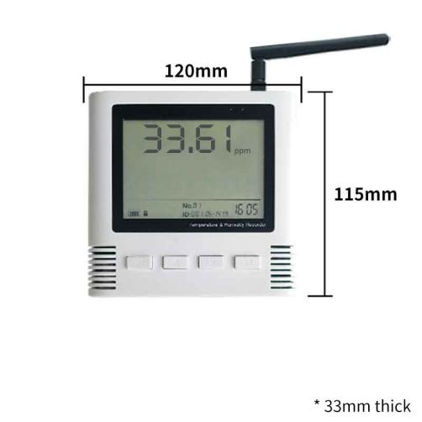

- GPRS / WIFI version
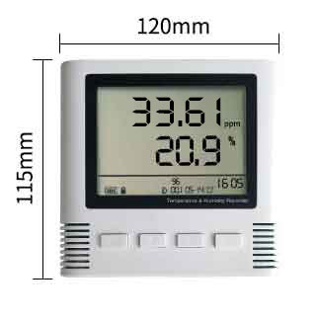

III Operation Panel and Interface
3.1 Operation panel description
On the front of the device, there is a 2.88-inch LCD screen. There are also four operation buttons, from left to right: the Menu button, the up button, the down button, and the OK button. There are two lights on the LCD screen: the link light and the alarm light The link light indicates that the device is currently in the link state, and the alarm light will only light up when an alarm occurs, as shown in the figure:
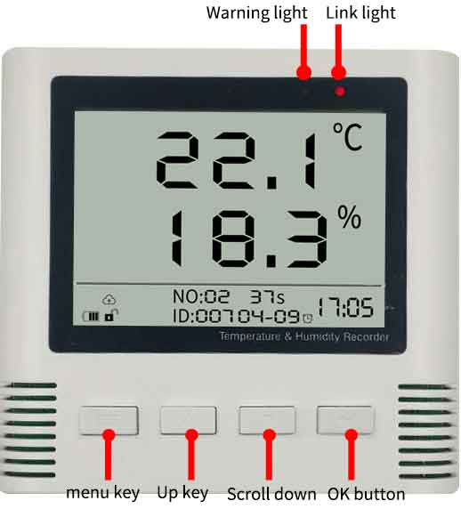
There are several indicators on the LCD that indicate the relevant functions, as shown in the table below.
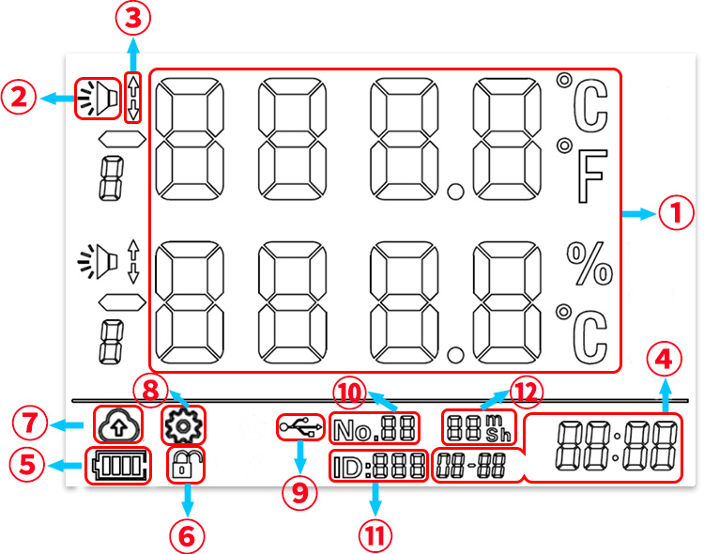
LCD screen marking
Serial number | Description
1 | Display data in real time
2 | Alarm display
3 | Upper / lower alarm
4 | Real time (month-day-hour-minute)
5 | Device power
6 | Locked state (locked state cannot be set)
7 | NB-IOT / GPRS / 4G signal strength
8 | WIFI signal strength
9 | Whether to enable the active reporting function (not applicable to version 485)
10 | Configuration status
11 | USB connection (useless in this version)
12 | Baud rate, 96 for 9600bps, 48 for 4800bps, 24 for 2400bps (485 version)
12 | Transmission sequence number (increase by 1 for each report, and it will be reset to zero if it exceeds 100) (Ethernet version)
12 | System status bit (GPRS / WIFI / NB-IOT version)
13 | Device modbus ID (485 version applicable)
14 | Next active countdown (485/NB-IOT version not applicable)
3.2 Device Interface Description
The following figure is a description of the device interface. As shown in the figure, the device interface is below, from left to right, SIM card slot, RJ45 network port, network configuration reset button (both versions are useless), DC power interface, USB interface.
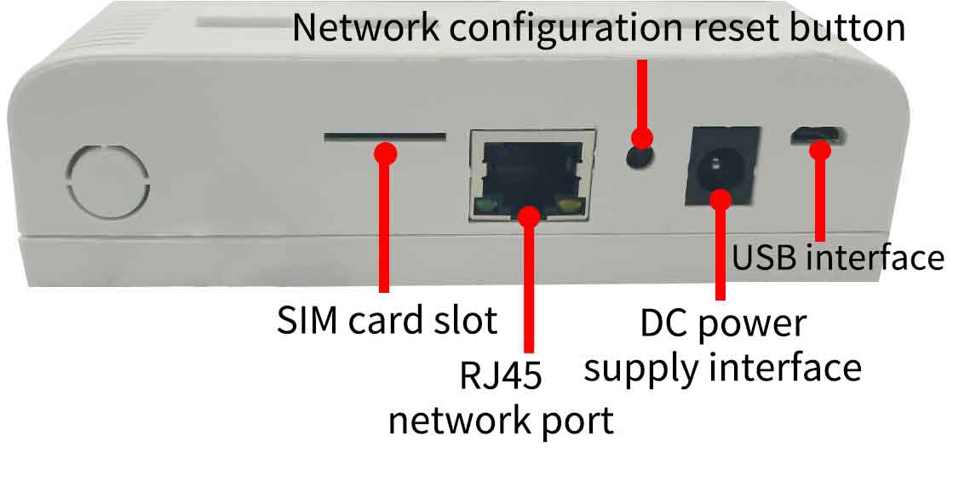

* The interface description in the figure above is a collection of the above versions. You should purchase the device version when using it.
3.3 Equipment Installation Instructions
There are two sets of hoist holes on the back of the device. The hole spacing is 96mm. The customer only needs to insert two holes with a spacing of 96MM at the fixed position of the wall, and install the expansion screws to complete the installation.
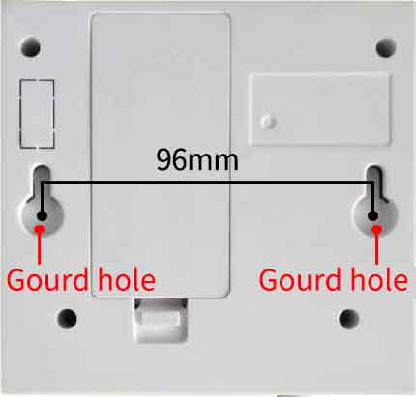
The installation location needs to pay attention to the following items:
1, the transmitter should be placed as vertical as possible
2. The installation height is the environmental area where the human body is sitting high or mainly requires measurement.
Please also pay attention to the following precautions:
1. Avoid installing in a zone that is easy to transfer heat and directly cause temperature difference with the area to be tested. Otherwise, the temperature and humidity measurement will be inaccurate.
2, installed in a stable environment, avoid direct lighting, away from windows and air conditioning, heating and other equipment, to avoid straight to the window, door.
3, try to stay away from high-power interference equipment, so as not to cause measurement inaccuracies, such as inverter / motor.
IV System Menus and Settings
4.1 Button function description
Button | Description | Operation mode
Menu button | Used to bring up the system configuration menu or return to the main interface in the system configuration menu. | Short press
Up button | Used to scroll up in the menu or to decrease the value. | Short press
Down button | Used to scroll down pages in the menu, or to increase the value. | Short press
OK button | Used to save modified values, or enter the next level configuration menu | Short press
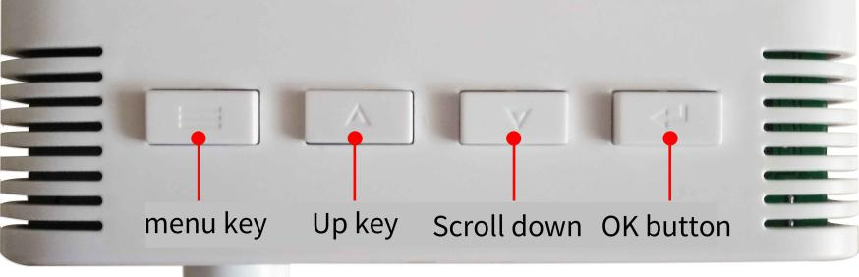
4.2 Configuration function to unlock
To prevent the parameters from being accidentally changed, the device is locked after it is powered on. At this time, the lock icon is locked. To configure the configuration menu, you need to unlock the device first.
First press and hold the up button for 3 seconds, then release, then press and hold the button for 3 seconds and release to unlock. The lock icon is unlocked.
In the unlocked state, press and hold the up button for 3 seconds on the main interface to release, and then press and hold the button for 3 seconds to change back to the locked state.

Figure 7
4.3 System status indication
This section applies to WIFI and GPRS versions
(1) WIFI communication method
A number similar to No.XX will be displayed on the screen. This number is the status bit of the system and is used to indicate the current system status. It can be used for troubleshooting. The specific status meanings are shown in the following table:
Status indication | Status meaning
No.00 | Power on the system
No.01 | Waiting for WIFI to connect to the router
No.02 | WIFI is connected to the server
No.03 | WIFI has obtained IP (normal state)
No.81 | Enter smart configuration state
No.31 | Enter system upgrade
(2) GPRS communication method
A number similar to No.XX will be displayed on the screen. This number is the status bit of the system and is used to indicate the current system status. It can be used for troubleshooting. The specific status meanings are shown in the following table:
Status indication | Status meaning
No.00 | Power on the system
No.01 | GRRS system is powered on
No.02 | GPRS initialization is complete
No.03 | SIM card search is complete
No.04 | SIM card check completed
No.05 | GPRS network access succeeded
No.61 | Go to initial setup
No.62 | Set up primary and secondary server centers
No.63 | Finish setting heartbeat parameters
No.64 | Save the initial settings
No.65 | Restarted successfully, initial settings have been saved
No.31 | Enter system upgrade
4.4 Configuration Menu Introduction
Under the temperature and humidity display interface and the unlocked state, press the Menu button to enter the configuration menu. At this time, the temperature and humidity information is no longer displayed on the interface, but the word ConF 01 is displayed. At this time, enter the configuration menu, press the page up or down. The Page Up button allows you to select different configuration submenus.

Configuration menu | Introduction | Under function
ConF 01 | Time setting | Modify the year, month, day, hour, minute and second
ConF 02 | Communication settings | Modify device slave station number and baud rate (version 485)
ConF 02 | Escalation settings | Modify reporting interval (GPRS / NB-IOT version)
ConF 02 | Escalation settings | Modify the reporting interval (the reporting interval must not be less than one minute) (WIFI version)
ConF 02 | Escalation settings | Modify the device ID, whether to report actively, and the reporting interval (Ethernet version)
ConF 03 | Alarm system | Modify the alarm switch, upper alarm limit, lower alarm limit, and fallback value
ConF 04 | Alarm system | Modify the alarm switch, upper alarm limit, lower alarm limit, and fallback value
ConF 05 | Probe fine-tuning settings | Modify fine-tuning values
4.5 Time setting
In the configuration menu, select ConF 01 time setting item and press OK button to enter the time setting. The time setting is divided into six items, from F1 to F6 decibels for year, month, day, hour, minute and second. Each item can be adjusted up or down by the up and down keys, press OK to confirm the configuration and proceed to the next configuration. When F6 is configured, it will take effect automatically and return to the main interface.

Year setting table
Configuration submenu | Introduction | Range
ConF 01-F1 | Annual revision | 2000-2099
ConF 01-F2 | Month modification | 1-12
ConF 01-F3 | Day modification | 1-31
ConF 01-F4 | Time modification | 0-59
ConF 01-F5 | Sub-modification | 0-59
ConF 01-F6 | Second modification | 0-59
* GPRS / Ethernet / 4G / NB-IOT automatically obtains network time
4.6 Escalation settings
(1)485 communication method
The report option parameters are shown in the following table:
Configuration Submenu | Introduction Scope | Scope
ConF 02-F1 | Modbus ID (slave number) | 1-252
ConF 02-F2 | Baud rate | 2400/4800/9600
(2) GPRS/WIFI/NB-IOT communication method
Configuration Submenu | Introduction Scope | Scope
ConF 02-F1 | Reporting interval | 60-1800 seconds
(3) Ethernet communication method
Configuration Submenu | Introduction Scope | Scope
ConF 02-F1 | TCP Modbus ID | 0-252
ConF 02-F2 | Whether to actively report | On / Off
ConF 02-F3 | Reporting interval | 10-1800 seconds
4.7 Alarm settings
The option parameters are shown in the following table:
Configuration Submenu | Introduction Scope | Scope
ConF 03-F1 | Whether to turn on the alarm | On / Off
ConF 03-F2 | Alarm upper limit | Adjustable
ConF 03-F3 | Lower alarm limit | Adjustable
ConF 03-F4 | Alarm fall | Adjustable
The option parameters are shown in the following table:
Configuration Submenu | Introduction Scope | Scope
ConF 04-F1 | Whether to turn on the humidity alarm | On / Off
ConF 04-F2 | Alarm upper limit | Adjustable
ConF 04-F3 | Lower alarm limit | Adjustable
ConF 04-F4 | Alarm fall | Adjustable
The alarm trigger logic is to trigger an alarm when the data is greater than the upper alarm limit or lower than the lower alarm limit, the screen indicates the alarm icon and the cause of the alarm (above the upper limit or lower limit), and the buzzer alarms.
The setting of the fallback value is a condition for eliminating alarms to prevent frequent triggering of alarms. The condition to eliminate the alarm from the alarm state is that the alarm can be canceled when the data is less than the upper alarm limit minus the fall value and the data is greater than the lower alarm limit plus the fall value.
4.8 Probe fine-tuning settings
The probe trimming option can linearly compensate the data to compensate for individual or environmental differences that may exist in the probe.Temperature and humidity alarm settings.
Configuration Submenu | Introduction Scope | Scope
ConF 05-F1 | Fine-tuning | Adjustable
ConF 05-F2 | Fine-tuning | Adjustable
V Configuration Software Installation and Use
(1) 485 communication method
After the sensor is correctly connected to the computer via USB to 485 and provides power, you can see the correct COM port in the computer (see the COM port in "My Computer-Properties-Device Manager-Port").
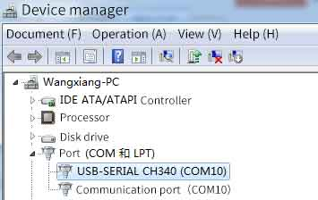
As shown in the figure above, your serial number is COM10 at this time, please remember this serial port, you need to fill in this serial number in the sensor monitoring software.
If the COM port is not found in the device manager, it means that you have not plugged in the USB to 485 or the driver is not installed properly. Please contact a technician for help.
The software interface is shown in the figure:
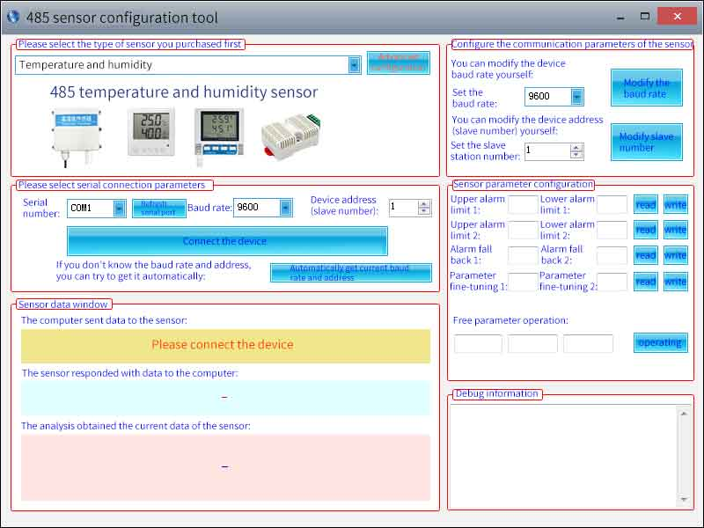
After opening the software, first select the "Sensor Type" at the top of the software, then obtain the serial port number and select the correct serial port according to the method in section 3.1.1, and then click "Automatically obtain the current baud rate and address" to automatically detect the current All devices and baud rates on the 485 bus. Please note that when using software to obtain automatically, you need to ensure that there is only one sensor on the 485 bus. Then click "Connect Device" to get sensor data information in real time.
In the case of disconnecting the “device connection”, click “Modify baud rate and modify slave number” in “Configure Sensor Communication Parameters” to complete the relevant settings. Please note that please restart the device after setting, and then “Get current automatically” "Baud rate and address", you can find that the address and baud rate have been changed to the address and baud rate you need.
(2) WIFI communication method
First you need to decompress our sensors into a separate folder, do not miss the files, please make sure that your computer's .Net version is 2.0 and above, and all versions of Win7SP1 and above are pre-installed. Net2.0 version, XP or earlier Win7 please install .Net2.0.
As shown in the figure below, the software interface is divided into the following parts. The left side is the device search and operation information display area, and the middle is the configuration area. You can perform basic device configuration, sensor debugging, and firmware upgrade.
When using, click Search for a device. At this time, all online devices will be displayed in the device list, and then double-click the device you need to access in the device list to get the current basic configuration of the device. Please note that you must first search for the device and double-click the device before each step, as shown below.
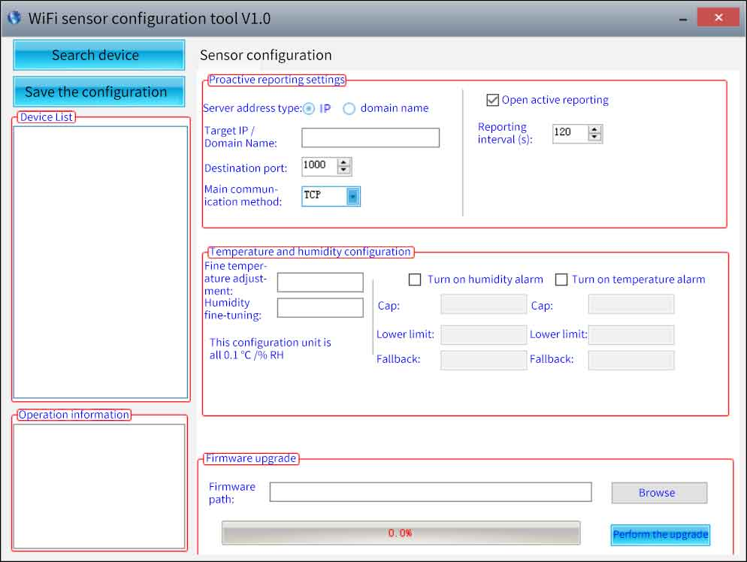
(3) Ethernet communication method
First you need to decompress our sensors into a separate folder, do not miss the files, please make sure that your computer's .Net version is 2.0 and above, and all versions of Win7SP1 and above are pre-installed. Net2.0 version, XP or earlier Win7 please install .Net2.0.
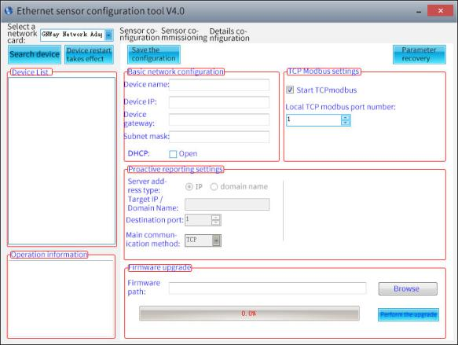
The software interface is divided into the following parts. As shown in the figure, the device search and operation information display area is on the left, and the configuration area is in the middle. The basic configuration of the device, sensor debugging and firmware upgrade can be performed.
Please note that the correct network card should be selected first, especially when your computer has wired network card and wireless network card. Then click Search for devices, and all the online devices will be displayed in the device list, and then double-click the devices you need to access in the device list to get the current basic configuration of the device. Please note that you must first search for the device and double-click the device before each step, as shown below.
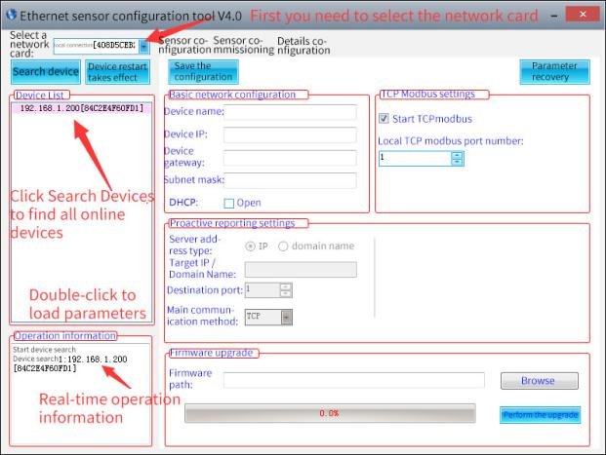
You can modify the specified parameters and click after modifying the parameters.
On the sensor detailed configuration page, you can set the probe parameter fine-tuning. At the same time, you can choose to enable or disable the temperature and humidity alarm, the upper and lower temperature and humidity alarm settings, and the alarm fallback value settings.
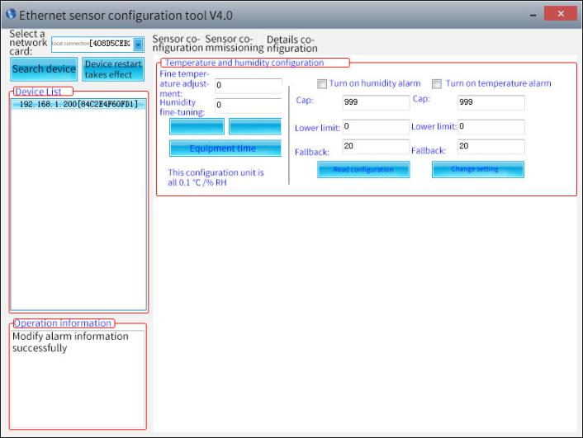
The system works by default in TCP modbus mode. If you need to switch to the active upload mode, please follow the steps below, and pay attention to the order of the steps. Otherwise, the configuration will fail.
① Set the reporting protocol to 1 on the sensor debugging page, and modify the reporting interval to your desired interval.
② On the sensor configuration page, uncheck the option to enable TCPmodbus, and set the active report setting to save the configuration.
If you need to switch back to TCPmodbus mode, please follow the steps below, pay attention to the order of the steps, otherwise the configuration will fail.
① On the sensor configuration page, select the option to enable TCPmodbus to save the configuration.
② Set the reporting protocol to 0 on the sensor debugging page.

VI Device data on the cloud
6.1 Introduction to Jingxun Cloud

Jingxun Cloud, a universal IoT cloud platform developed by Jingxun Changtong, based on industry solutions, solves the problem of traditional cloud platforms that focus on light links and light experience. Based on the links, it upgrades the display effect and style of the previous paragraph and integrates more than ten The industry interface template is a set of IoT systems that integrates solutions, data collection, early warning release, remote control, and data analysis. Jingxun Cloud provides data recording, query, export, comparison and other functions, mainly providing customers with a one-stop joining service at the application layer.
6.2 Jingxun Cloud Advantage
(1) Stability: High stability, the overall system availability is greater than 99.7%, the database application availability is greater than 99.8%, and it is regularly maintained.
(2) Ease of operation: Provide friendly user management and use circles
(3) Reliability: When designing the system, ensure the reliability of the system by selecting excellent products and adopting necessary technical means
(4) Compatibility: Other company's products are based on our server agreement, and the data can also be viewed on our platform.
(5) "Thousands of people": It has a privatized deployment and provides two entrances, normal entrance and neutral entrance. After entering from the neutral entrance, the interface information that customers see is the information set by customers
(6) WeChat Mini Program: You can use mobile WeChat to easily and conveniently view device status, data, and device binding locations.
6.3 Sensor Data Query
When you purchase a sensor with a report function, you can remotely view the data through Jingxin Cloud Server, which is convenient and fast.
The sensor device establishes a connection with Jingxin Cloud Server through the 4G / NB-IOT network module, and reports the data to the Cloud Server according to the default frequency (frequency adjustable).
You only need to log in to the server with the registered Jingxun Cloud account, and then use the unique "identity ID" of each host to query the device's data.
At the same time, the platform also has an alarm function. You only need to set the alarm value through the platform, and the monitoring data exceeds the alarm value. The platform will notify you via SMS or QQ mailbox, making it easier and faster to monitor the data.
Note: You can contact our after-sales staff to understand the specific functions of the platform.

