INSTRUCTION MANUAL
Duct type ozone sensor
JXBS-3005-O₃
VER1.0

WeihaiJXCTElectronicTechnologyCo.,Ltd.

Ⅰ Brief Introduction
1.1 Product Overview
Ducted ozone sensors are specifically designed for plug-in pipe gas measurement. The stainless steel air duct and stainless steel flange are used as the plug-in structure, and the professional test ozone concentration sensor probe is used as the core detection device; it has a wide measurement range, high accuracy, good linearity, good versatility, convenient use, convenient installation and transmission Long distance and moderate price.
1.2 Primary Parameters
TABLE 1 Primary Parameters
PARAMETERS | TECHNICAL SPECIFICATIONS
MEASURING RANGE | 0-20ppm/0-100ppm
MEASURING MODE | Electrochemical sensor
PRECISION | 3%F.s
RESPONSE TIME | less than 15 seconds
WARRANTY PERIOD | 2 years ( Host ) / 1 year ( Sensor )
COMMUNICATION PORT | Analog (voltage / current) / digital (RS485)
POWER SUPPLY | 12-24V DC
POWER CONSUMPTION | ≤1W
OPERATING TEMPERATURE | -30-50 ℃(-20-40℃ continued)
WORKING HUMIDITY ENVIRONMENT | 0-100%RH(15-95%RH）
DUCT LENGTH | 200mm
CASE SIZE | 110 x 85 x 44mm³
1.3 Probe Parameters And Selection
NO. | MANUFACTURER | RANGE | RESOLUTION | LIFE
20P | Domestic electrochemical probe | 20ppm | 200ppb | >2 years
20PL | SPEC | 20ppm | 100ppb | >2 years
20PE | HONEYWELL | 100ppm | 20ppb | >2 years
01PB | Domestic semiconductor | 1000ppb | 10ppb | >2 years
The above life is the reference value in the case of temperature 23 ± 3 ℃, humidity 40 ± 10% RH, and concentration <5%
1.4 Analog communication parameters
Parameter | Index
Current output type | 4-20mA
Current output load | ≤600Ω
Voltage output type | 0-5V/0-10V
Voltage output load | ≤250Ω
1.6 Digital communication parameters
Parameter | Index
Communication Interface | RS485
Baud rate | 2400/4800/9600
Protocol | Modbus RTU

Ⅱ Hardware Connections
2.1 CHECKING BEFORE INSTALLATION
Check the list of devices before installation:
TABLE 3 List of Devices
Name | Number
THE SENSOR DEVICE | 1
12V POWER ADAPTER（Optional） | 1
THE USB TO 485 DEVICE（Optional） | 1
WARRANTY CARD / CERTIFICATE | 1
2.2 Interface Description
The power interface is wide voltage power input 12-24V. When wiring the 485 signal line, pay attention that the two A / B lines cannot be reversed, and the addresses between multiple devices on the bus must not conflict.
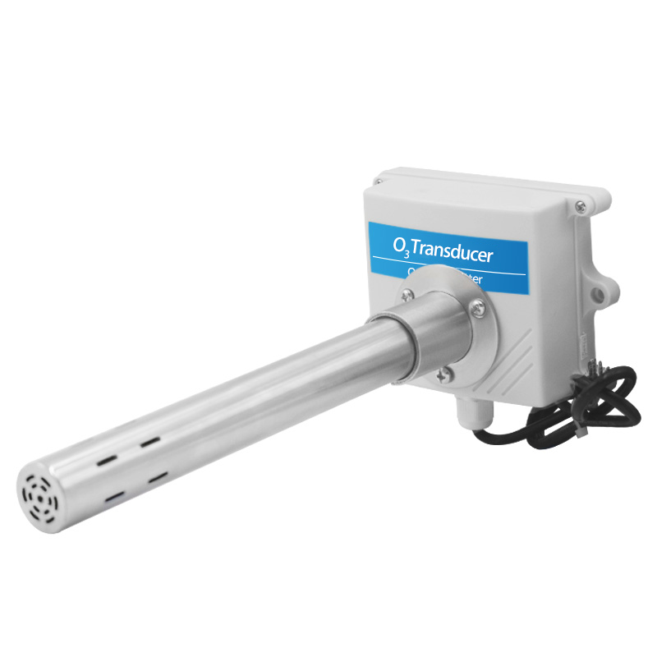
 | Line Color |  | Description
Power | Brown |  | Power supply Positive ( 12-24V DC )
Power | Black |  | Power supply Negative
Communication | Yellow ( Gray ) |  | 485-A
Communication | Blue |  | 485-B
The power interface is wide voltage power input 12-24V. For analog products, pay attention to the positive and negative signal lines. Do not reverse the positive / negative current / voltage signal lines.
 | Line Color |  | Description
Power | Brown |  | Power supply Positive ( 12-24V DC )
Power | Black |  | Power supply Negative
Communication | Yellow ( Gray ) |  | Positive voltage / current output
Communication | Blue |  | Voltage / current output negative
We provide default cable length of 0.6 meters, you can extend the cable yourself according to your needs.
2.3 Installation Description
The diameter of the duct of the duct sensor is 25mm. The duct sensor is delivered with a set of mounting flanges for fixing to the designated equipment pipe wall. The flanges are fixed by three 3.5mm mounting screw holes. Customers can use 3mm bolts or 3mm self-tapping screws to install according to the situation
There are screws with a distance of 105mm on the sensor housing, which can also be fixed by the fixing screws here.
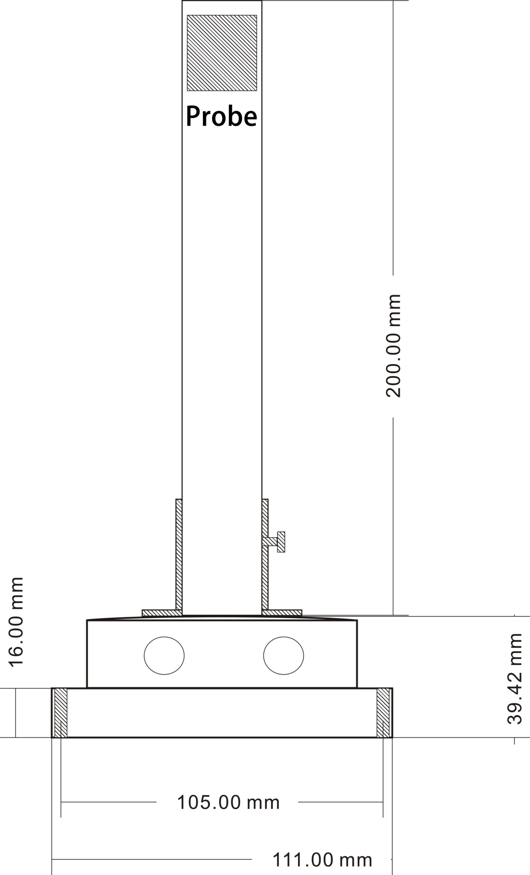
The following figure shows the installation diagram of the flange. After fixing the flange, the customer can use the screws on the flange post to fix the sensor.
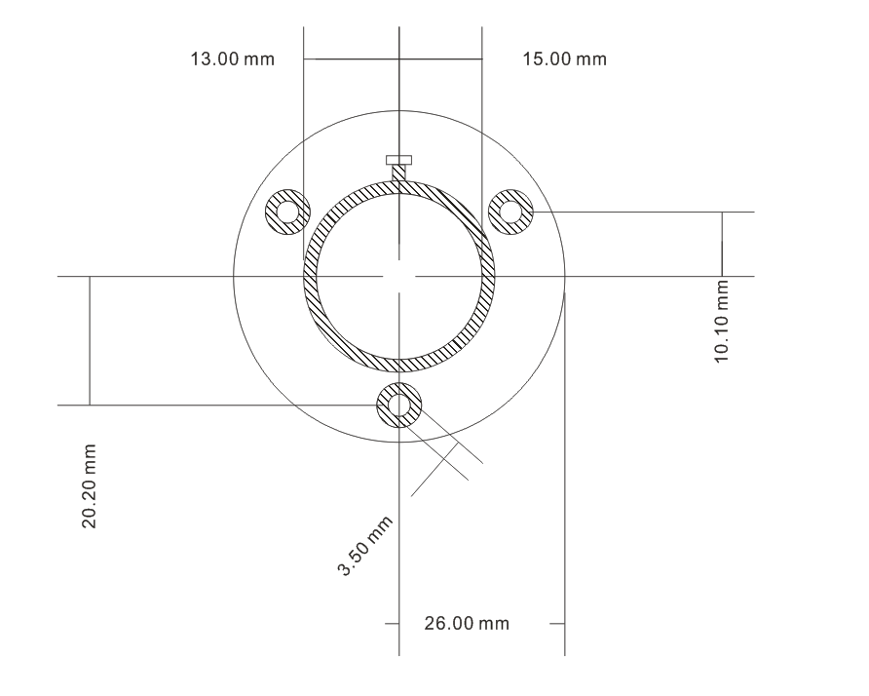
The following figure shows the installed reference style. The specific installation forms are various. Customers can choose a reasonable installation method according to the site conditions:
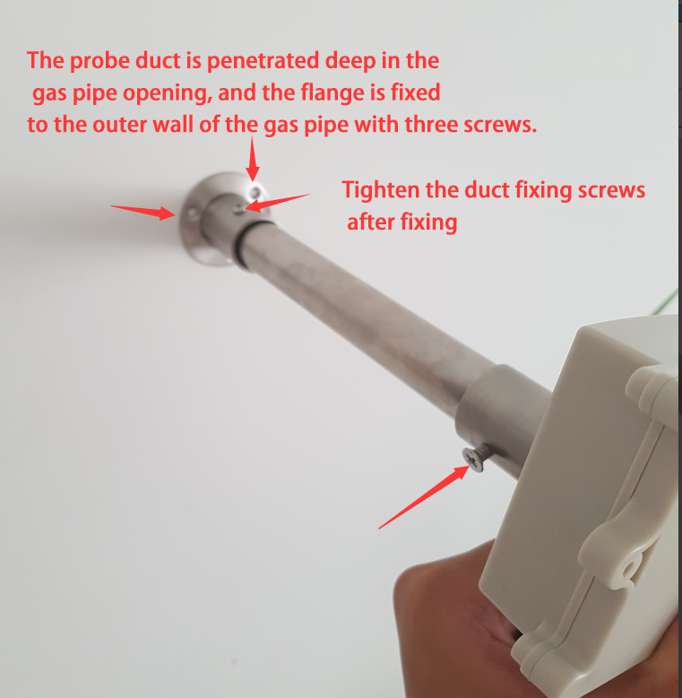

Ⅲ Digital sensor communication protocol
3.1 Communication Basic Parameters
PARAMETERS | CONTENT
Protocol | Modbus RTU
Data bits | 8 bit
Parity bit | No
Stop bit | 1 bit
Error checking | CRC (redundant loop code)
Baud rate | 2400 bps/ 4800 bps/ 9600 bps can be set factory defaults to 9600 bps
3.2 Data frame format definition
Modbus-RTU communication protocol is adopted, the format is as follows:
Time for initial structure ≥ 4 bytes
Address code = 1 byte
Function code = 1 byte
Data area = N bytes
Error check = 16-bit CRC
Time to end structure ≥ 4 bytes
Address code: It is the address of the transmitter and is unique in the communication network (factory default 0x01).
Function code: The function instruction of the command issued by the host, this transmitter only uses the function code 0x03 (reading register data).
Data area: The data area is the specific communication data. Note that the high byte of the 16bits data comes first!
CRC code: two-byte check code.
Inquiry frame
address code | function code | Register start address | Register length | Low check bit | Check code high
1 byte | 1 byte | 2 bytes | 2 bytes | 1 byte | 1 byte

Response frame
address code | function code | Number of valid bytes | Data area | Second data area | Nth data area
1 byte | 1 byte | 1 byte | 2 bytes | 2 bytes | 2 bytes
3.3 Register Address
Register Address | Plc Configuration Address | Content | Operation
0000H | 40001 | Humidity ( Unit 0.1%RH) | Read-Only
0001H | 40002 | Temperature ( Unit 0.1℃) | Read-Only
0006H | 40007 | Ozone ( unit 0.1ppm) | Read-Only
0100H | 40101 | Device Address (0-252) | R/W
0101H | 40102 | Baud Rate (2400/4800/9600) | R/W
3.4 Communication protocol examples and explanations
3.4.1 Read Device Address 0x01's Ozone Concentration
Inquiry Frame
Address Code | Function Code | Start Address | Data Length | CRC_L | CRC_H
0x01 | 0x03 | 0x00  0x06 | 0x00  0x01 | 0x64 | 0x0B
Answer Frames( For example, the reading is 18.9ppm )
Address Code | Function Code | Returns to The Number Of Valid Bytes | Ozone Value | Check Digit Low | Check Digit High
0x01 | 0x03 | 0x02 | 0x00  0xBD | 0x78 | 0x35
Ozone：
0xBD H ( hexadecimal ) =189=>Ozone=18.9ppm
3.4.2 Read Device Address 0x01's Temperature And Humidity Value
Inquiry Frame
Address Code | Function Code | Start Address | Data Length | CRC_L | CRC_H
0x01 | 0x03 | 0x00,0x00 | 0x00,0x02 | 0xC4 | 0x0B
Answer Frame(For example, read that the temperature is -10.1 ℃ and the humidity is 65.8% RH)
Address Code | Function Code | Number Of Valid Bytes | Humidity Value | Temperature Value | CRC_L | CRC_H
0x01 | 0x03 | 0x04 | 0x02  0x92 | 0xFF  0x9B | 0x5A | 0x3D
Temperature：
When the temperature is lower than 0 ℃, upload it in two's complement form
FF9BH ( hexadecimal ) =-101=> Temperature =-10.1 ℃
Humidity：
0292H ( hexadecimal ) =658=> Humidity =65.8%RH
3.4.3 Read Device Address 0x01's Temperature And Humidity, Ozone Concentration Value
Inquiry Frame
Address Code | Function Code | Start Address | Data Length | CRC_L | CRC_H
0x01 | 0x03 | 0x00,0x00 | 0x00,0x07 | 0x04 | 0x08
Answer Frame(E.g. read O3 value is 4ppm)
Address Code | Function Code | Number Of Valid Bytes | Humidity Value | Temperature Value
0x01 | 0x03 | 0x0E | 0x03  0x14 | 0x01  0x1B
8 Useless Bytes |  | Ozone Value | CRC_L | CRC_H
0x00 ... |  | 0x00  0x28 | 0x50 | 0x3B
Temperature：
011B H ( hexadecimal ) =283=> Temperature =28.3 ℃
Humidity：
0314 H ( hexadecimal ) =788=> Humidity =78.8%RH
Ozone：
0028 H ( hexadecimal ) =40=> Ozone =4ppm
3.5 O₃ measurement unit ppm and μg / m³ conversion
According to the calculation, the conversion relationship can be obtained, which is only valid for O₃:
1ppm =48/22.4=2.143mg / m³ =2143μg / m³
1ppb =48/22.4=2.143μg / m³
IV Meaning and Conversion of Analog Sensor Parameters
4.1 Analog 4-20mA Current Output
Current Value | O₃
4mA | 0ppm
20mA | 20ppm
The formula is P（O_{3）} = (I (current) -4mA) *1.25ppm
The unit of P is ppm and the unit of I is mA.
For example, the data collected in the current situation is 8.125mA, and the value of O₃ is calculated at the maximum range of 5.15ppm.
4.2 Analogue 0-10V Voltage Output
Voltage Value | O₃
0V | 0ppm
10V | 20ppm
The formula is P（O_{3）} = V (voltage) /500ppm
The unit of P is ppm and the unit of V is mV.
For example, the data collected in the current situation is 3515mV, and the value of O₃ calculated at this time is 7.03ppm.
4.3 Analogue 0-5V voltage output
Voltage Value | O₃
0V | 0ppm
5V | 20ppm
The formula is P（O_{3）}=V(voltage)/250ppm
The unit of P is ppm and the unit of V is mV.
For example, the data collected in the current situation is 4228mV, and the calculated value of O₃ is 16.91ppm.
V Frequently Asked Questions and Quality Assurance
5.1 Digital devices cannot be connected to a PLC or computer
The possible reasons are as follows:
● The computer has multiple COM ports, and the selected port is incorrect.
● The device address is wrong, or there are devices with duplicate addresses (the factory defaults are all 1).
● Baud rate, check mode, data bit, stop bit error.
● The host polling interval and waiting for response time are too short, both need to be set above 200ms.
● The 485 bus is disconnected, or the A and B wires are reversed.
● Too many devices or wiring is too long, you should supply power nearby, add 485 booster, and increase 120Ω terminal resistance.
● ● The USB to 485 driver is not installed or damaged.
● ● Equipment is damaged.
5.2 Possible Causes of No Analog Output or Output Error
● The measurement error caused by the wrong range corresponds to the PLC calculation. Please refer to the technical specifications in Part I for the range.
● The wiring method is incorrect or the wiring sequence is wrong.
● The distance between the transmitter and the collector is too long, causing signal disturbance.
● The PLC acquisition port is damaged.
● Equipment is damaged.
5.3 Warranty and after sales
The warranty terms are in accordance with the sensor after-sales clauses of Weihai Jingxun Changtong Electronic Technology Co., Ltd. The warranty period is two years for the main circuit of the sensor, one year for the gas-sensitive probe, and three months for the accessories (shell, plug, cable, etc.)

