INSTRUCTION MANUAL
Duct type oxygen sensor
JXBS-3005-O₂
VER1.0

WeihaiJXCTElectronicTechnologyCo.,Ltd.

Ⅰ Brief Introduction
1.1 Product Overview

Ducted oxygen sensors are designed specifically for plug-in pipe gas measurement. The plug-in structure with stainless steel gas guide pipe combined with stainless steel flange is adopted as the core detection device, which has the characteristics of wide measuring range, high precision, good linearity, good generality, convenient use, easy installation, long transmission distance and moderate price.
1.2 Primary Parameters
PARAMETERS | TECHNICAL SPECIFICATIONS
MEASURING RANGE | 0-30%/0-100%
MEASURING MODE | Electrochemical sensor
PRECISION | 3%F.s
RESPONSE TIME | less than 15 seconds
WARRANTY PERIOD | 2 years ( Host ) / 1 year ( Sensor )
BAND RATE | 2400/4800/9600
COMMUNICATION PORT | Analog (voltage / current) / digital (RS485)
POWER SUPPLY | 12-24V DC
POWER CONSUMPTION | ≤0.15W（@12V DC , 25℃）
OPERATING TEMPERATURE | -30-50 ℃（-20-40 ℃ continued）
WORKING HUMIDITY ENVIRONMENT | 15-95%RH
DUCT LENGTH | 200mm
CASE SIZE | 110 x 85 x 44mm³
1.3 Probe Parameters And Selection
NO. | MANUFACTURER | RANGE | RESOLUTION | LIFE
30A | British Imports of CITY | 30% | 0.1% | >2 years
30L | Long life of Japanese imports | 100% | 0.1% | >2 years
1.4 Analog communication parameters
Parameter | Index
Current output type | 4-20mA
Current output load | ≤600Ω
Voltage output type | 0-5V/0-10V
Voltage output load | ≤250Ω
1.5 Digital communication parameters
Parameter | Index
Communication Interface | RS485
Baud rate | 2400/4800/9600
Protocol | Modbus RTU

Ⅱ Hardware Connections
2.1 CHECKING BEFORE INSTALLATION
Check the list of devices before installation:
TABLE 3 List of Devices
Name | Number
THE SENSOR DEVICE | 1
12V POWER ADAPTER（Optional） | 1
THE USB TO 485 DEVICE（Optional） | 1
WARRANTY CARD / CERTIFICATE | 1
2.2 Interface Description
The power interface is wide voltage power input 12-24V. When wiring the 485 signal line, pay attention that the two A / B lines cannot be reversed, and the addresses between multiple devices on the bus must not conflict.
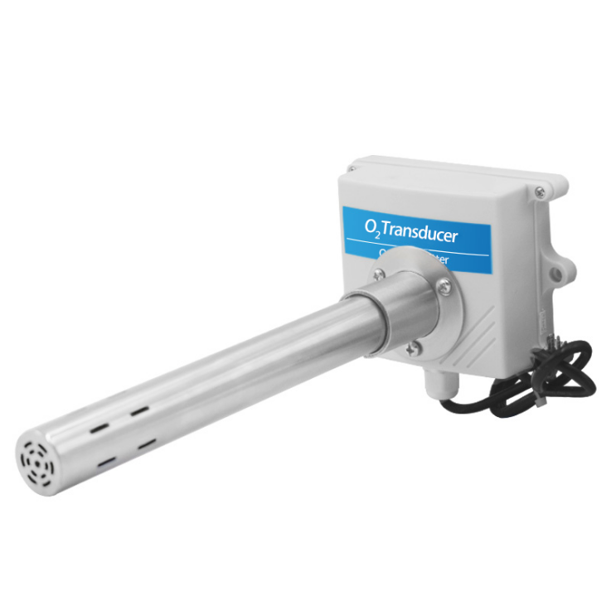
 | Line Color |  | Description
Power | Brown |  | Power supply Positive ( 12-24V DC )
Power | Black |  | Power supply Negative
Communication | Yellow ( Gray ) |  | 485-A
Communication | Blue |  | 485-B
The power interface is wide voltage power input 12-24V. For analog products, pay attention to the positive and negative signal lines. Do not reverse the positive / negative current / voltage signal lines.
 | Line Color |  | Description
Power | Brown |  | Power supply Positive ( 12-24V DC )
Power | Black |  | Power supply Negative
Communication | Yellow ( Gray ) |  | Positive voltage / current output
Communication | Blue |  | Voltage / current output negative
We provide default cable length of 0.6 meters, you can extend the cable yourself according to your needs.
2.3 Installation Description
The diameter of the duct of the duct sensor is 25mm. The duct sensor is delivered with a set of mounting flanges for fixing to the designated equipment pipe wall. The flanges are fixed by three 3.5mm mounting screw holes. Customers can use 3mm bolts or 3mm self-tapping screws to install according to the situation
There are screws with a distance of 105mm on the sensor housing, which can also be fixed by the fixing screws here.
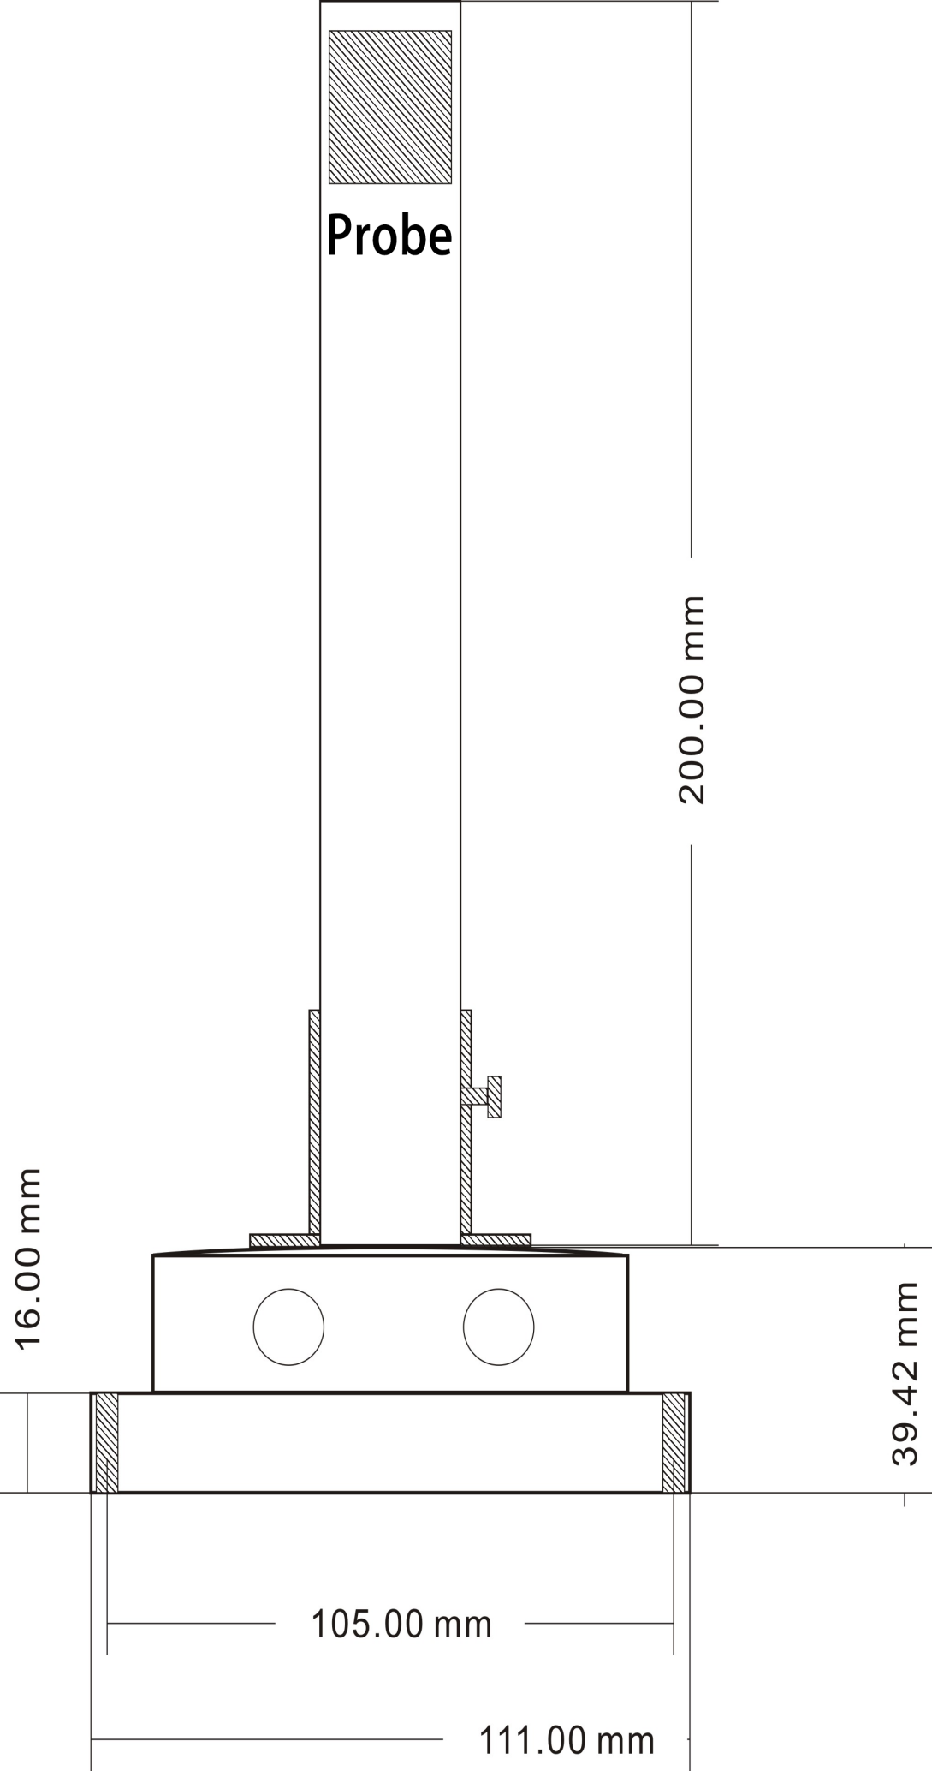
The following figure shows the installation diagram of the flange. After fixing the flange, the customer can use the screws on the flange post to fix the sensor.
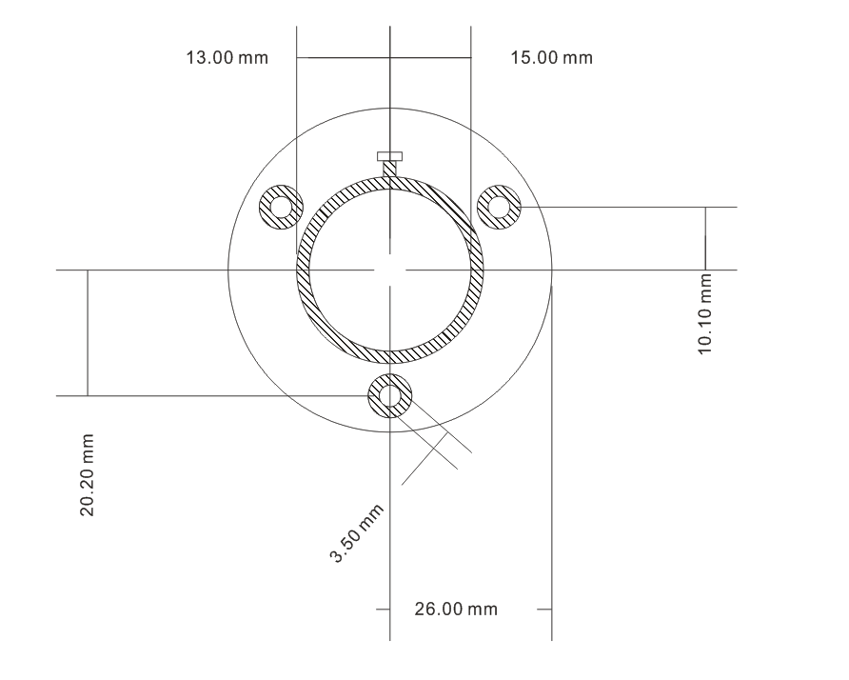
The following figure shows the installed reference style. The specific installation forms are various. Customers can choose a reasonable installation method according to the site conditions:
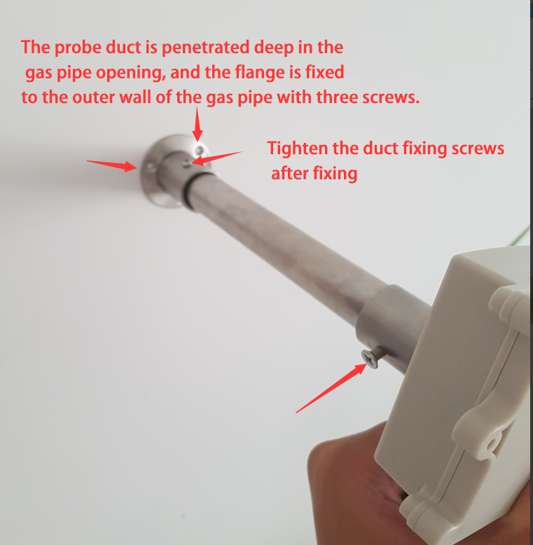

Ⅲ Digital sensor communication protocol
3.1 Communication Basic Parameters
PARAMETERS | CONTENT
Protocol | Modbus RTU
Data bits | 8 bit
Parity bit | No
Stop bit | 1 bit
Error checking | CRC (redundant loop code)
Baud rate | 2400 bps/ 4800 bps/ 9600 bps can be set factory defaults to 9600 bps
3.2 Data frame format definition
Modbus-RTU communication protocol is adopted, the format is as follows:
Time for initial structure ≥ 4 bytes
Address code = 1 byte
Function code = 1 byte
Data area = N bytes
Error check = 16-bit CRC
Time to end structure ≥ 4 bytes
Address code: It is the address of the transmitter and is unique in the communication network (factory default 0x01).
Function code: The function instruction of the command issued by the host, this transmitter only uses the function code 0x03 (reading register data).
Data area: The data area is the specific communication data. Note that the high byte of the 16bits data comes first!
CRC code: two-byte check code.
Inquiry frame
address code | function code | Register start address | Register length | Low check bit | Check code high
1 byte | 1 byte | 2 bytes | 2 bytes | 1 byte | 1 byte

Response frame
address code | function code | Number of valid bytes | Data area | Second data area | Nth data area
1 byte | 1 byte | 1 byte | 2 bytes | 2 bytes | 2 bytes
3.3 Register Address
Register Address | Plc Configuration Address | Content | Operation
0000H | 40001 | Humidity ( Unit 0.1%RH) | Read-Only
0001H | 40002 | Temperature ( Unit 0.1℃) | Read-Only
0006H | 40007 | Oxygen ( unit 0.1%) | Read-Only
0100H | 40101 | Device Address (0-252) | R/W
0101H | 40102 | Baud Rate (2400/4800/9600) | R/W
3.4 Communication protocol examples and explanations
3.4.1 Read Device Address 0x01's Oxygen Concentration
Inquiry Frame
Address Code | Function Code | Start Address | Data Length | CRC_L | CRC_H
0x01 | 0x03 | 0x00  0x06 | 0x00  0x01 | 0x64 | 0x0B
Answer Frames( For example, the reading is 18.9% )
Address Code | Function Code | Returns to The Number Of Valid Bytes | Oxygen Value | Check Digit Low | Check Digit High
0x01 | 0x03 | 0x02 | 0x00  0xBD | 0x78 | 0x35
Oxygen：
0xBD H ( hexadecimal ) =189=>Oxygen=18.9%
3.4.2 Read Device Address 0x01's Temperature And Humidity Value
Inquiry Frame
Address Code | Function Code | Start Address | Data Length | CRC_L | CRC_H
0x01 | 0x03 | 0x00,0x00 | 0x00,0x02 | 0xC4 | 0x0B
Answer Frame
Address Code | Function Code | Number Of Valid Bytes | Humidity Value | Temperature Value | CRC_L | CRC_H
0x01 | 0x03 | 0x04 | 0x00  0xFE | 0x00  0xAF | 0xDB | 0xBF
Temperature：
00AF H ( hexadecimal ) =175=> Temperature =17.5 ℃
Humidity：
00FE H ( hexadecimal ) =254=> Humidity =25.4%RH
3.4.3 Read Device Address 0x01's Temperature And Humidity, Oxygen Concentration Value
Inquiry Frame
Address Code | Function Code | Start Address | Data Length | CRC_L | CRC_H
0x01 | 0x03 | 0x00,0x00 | 0x00,0x07 | 0x04 | 0x08
Answer Frame
Address Code | Function Code | Number Of Valid Bytes | Humidity Value | Temperature Value
0x01 | 0x03 | 0x0E | 0x03  0x14 | 0x01  0x1B
8 Useless Bytes |  | Oxygen Value | CRC_L | CRC_H
0x00 ... |  | 0x00  0x28 | 0x50 | 0x3B
Temperature：
011B H ( hexadecimal ) =283=> Temperature =28.3 ℃
Humidity：
0314 H ( hexadecimal ) =788=> Humidity =78.8%RH
Oxygen ：
0028 H ( hexadecimal ) =40=> Oxygen =4%

IV Meaning and Conversion of Analog Sensor Parameters
4.1 Analog 4-20mA Current Output
Current Value | O₃
4mA | 0ppm
20mA | 100ppm
The formula isP₍O₂₎ = (I (current) -4mA) *1.875%
where the unit of P is% and the unit of I is mA.
For example, the data collected in the current situation is 15.15 mA, and the value of O₂ is calculated at 20.9%.
The above is a 30% range calculation method, other ranges should be 4 mA for 0%,20mA for the maximum range linear conversion.
4.2 Analogue 0-10V Voltage Output
Voltage Value | O₂
0V | 0%
10V | 30%
The formula is P₍O₂₎= V (voltage) *0.003%
The unit of P is% and the unit of V is mV.
For example, the data collected in the current case is 6966 mV, at which time the value of the calculated O₂ is 20.9%.
The above is a 30% range calculation method, other ranges should be 0 V for 0%,10 V for the maximum range of linear conversion.
4.3 Analogue 0-5V voltage output
Voltage Value | O₂
0V | 0%
10V | 30%
The formula is P₍O₂₎ =V(voltage)*0.006%
The unit of P is % and the unit of V is mV.
For example, the data collected in the current situation is 3483mV, and the calculated value of O₂ is 20.9%.

V Appendix
5.1 Additional Product Instructions
《How to Use Multimeter-Assisted Debugging》: Multimeter is a very important auxiliary debugging tool, and it is necessary to use multimeter-Assisted debugging whenever you find errors in readings and your own expectations.
《Quantification Precision and Resolution Description of Analog Products》: The concept of quantization accuracy and resolution of analog products, how to calculate, how to select the range correctly.
《The source and elimination of the deviation of the analog product》: The cause of the error, the type of error and how the error is eliminated in the analog product when there is an error in the reading.
5.2 Warranty and aftermarket
The warranty terms are in accordance with the sensor after-sales clauses of Weihai Jingxun Changtong Electronic Technology Co., Ltd. The warranty period is two years for the main circuit of the sensor, one year for the gas-sensitive probe, and three months for the accessories (shell, plug, cable, etc.)

