INSTRUCTION MANUAL

DISSOLVED OXYGEN SENSOR

JXBS-3001-DO
VER2.0

WeihaiJXCTElectronicTechnologyCo.,Ltd.

Ⅰ Brief Introduction
1.1 Product Overview
The dissolved oxygen sensor uses Ethernet for transmission, which measures the oxygen content in the water in real time, and uses a network cable for transmission. The device supports two forms: active upload and TCP Modbus. This series of products make full use of the existing Ethernet network to achieve unlimited distance data collection and transmission and centralized control.
The water quality fluorescent dissolved oxygen sensor is a continuous monitoring instrument probe widely used in dissolved oxygen, saturation, oxygen partial pressure and temperature in solutions such as thermal power, chemical fertilizers, metallurgy, environmental protection, pharmaceuticals, biochemistry, food and tap water.
1.2 Product advantages
- Imported detection chip with fast response speed
- Small zero drift and good repeatability
- Low power consumption, long life
- The product has been tested by EMC and EMI, with strong anti-interference ability
- The equipment is stable, reliable and accurate in detection
- Remote cloud alarm monitoring
1.3 Product parameters
1.3.1Probe parameters
Parameter name | Parameter content
Response time | ≤10s
Measuring range | 0~20mg/L
Resolution | 0.01mg/L
Operating temperature | -20~50℃
Working humidity | 0~95% (relative humidity), non-condensing
1.3.2 Ethernet parameters
Parameter name | Parameter content
DC power supply | 12V-24V DC
POE power supply | 48V standard POE power supply (optional)
Transmission interface | RJ45 10M/100M adaptive
Communication protocol | Active report/TCP modbus
DNS dynamic resolution | support
Operating temperature | -20~50℃
Working humidity | 0~95% (relative humidity), non-condensing

Ⅱ Hardware Connections
2.1 CHECKING BEFORE INSTALLATION
Check the list of devices before installation:
TABLE 1 List of Devices
Name | Number
High-precision sensor | 1
Water quality probe | 1
12V POWER ADAPTER（Optional） | 1
WARRANTY CARD / CERTIFICATE | 1
2.2 Interface description
The equipment is divided into ordinary DC power adapter power supply type and POE centralized power supply type. The specific interfaces are as follows.
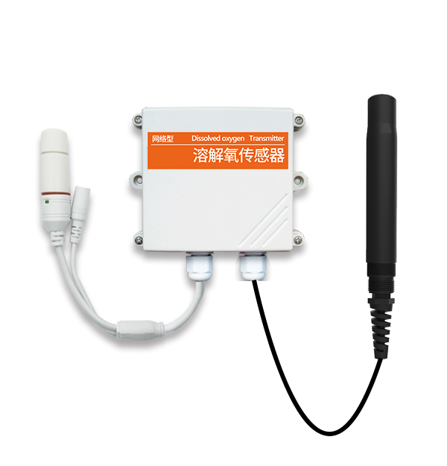
As shown in the figure above, it is a normal power supply version, which is divided into a DC port power supply port and a waterproof RJ45 network cable port.
The sensor of the common power supply mode needs to be connected to the DC power supply at the same time as the network cable is connected. The default 50cm wire is provided at the factory.
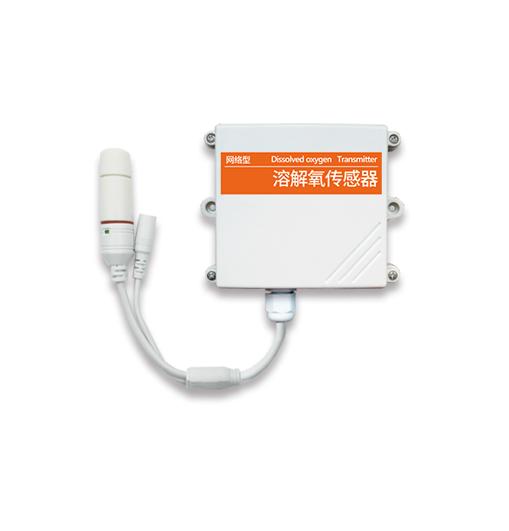
As shown in the figure above, it is a POE power supply version with a waterproof RJ45 port. When the POE is powered by the network sensor, there is only one network interface, you only need to plug the POE network cable into the network port.
Note that this device only supports standard 48V national standard POE switches, and does not support 24V non-standard switches. If you have special requirements, please contact the manufacturer. This POE power supply is compatible with two power supply modes, 1236 and 4578.
2.3 Installation instructions
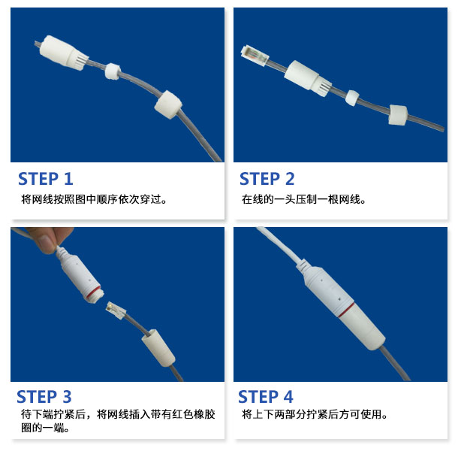
This product is equipped with a default RJ45 waterproof connector for outdoor use. As shown in the figure below, please pass the network cable through the waterproof head, then press the crystal head, then insert the network cable and tighten the waterproof connector.
If you have no requirements for waterproofing, you can simply plug in the finished network cable and use it without using the waterproof protective cover.
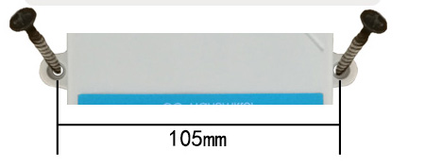
The wall-mounted prince shell is a wall-mounted installation. The installation holes are located in the middle of both sides of the device. The installation hole diameter is less than 4mm, and the hole distance is 105mm. It can be installed with 3mm self-tapping screws.
2.4 Installation matters
The installation location needs to pay attention to the following items:
1. The transmitter should be placed as vertically as possible to ensure that the sensor is below the transmitter when installing on the wall (the font on the transmitter is in the positive direction);
2. The installation height is the human sitting height or the environmental area where the measurement is mainly required.
At the same time, please pay attention to the following precautions:
1. Avoid installing in areas that are easy to transfer heat and will directly cause a temperature difference with the area to be measured, otherwise the sulfur dioxide measurement will be inaccurate.
2. Install in an area with stable environment, avoid direct sunlight, stay away from windows, air-conditioning, heating and other equipment, and avoid directly facing windows and doors.
3. Keep away from high-power interference equipment as much as possible to avoid inaccurate measurement, such as inverters/motors.

Ⅲ Configuration Software Installation and Use
Our company provides the supporting "Ethernet Software Configuration and Debugging Tool", which can conveniently use the computer to set up the Ethernet sensor, modify the network information, read the sensor value, etc.
3.1 Basic software use and device search
First of all, you need to unzip our sensor to a separate folder. Don’t miss the files. Please make sure that the .Net version of your computer is 2.0 and above. Win7SP1 and above are all pre-installed with .Net2.0 version, XP or earlier Please install .Net2.0 for Win7.
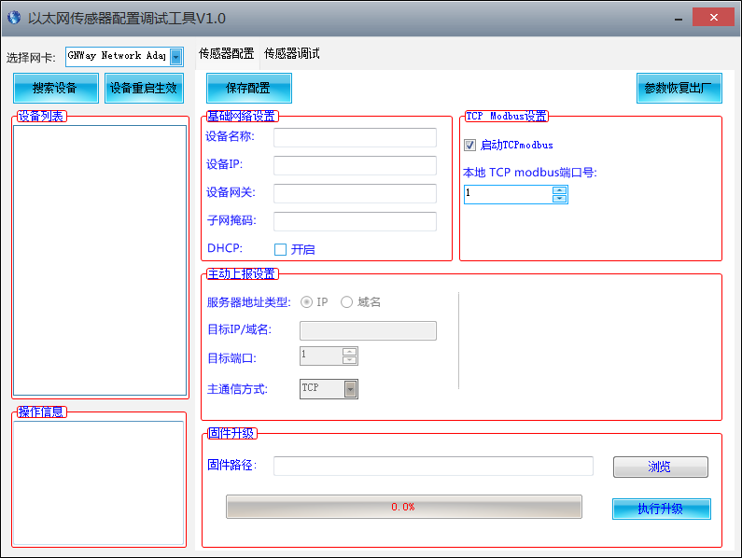
The software interface is divided into the following parts, as shown in the figure, the left is the device search and operation information display area, and the middle is the configuration area, which can carry out the basic configuration of the device, sensor debugging and firmware upgrade.
Please note that you should first select the correct network card when using it, especially when your computer has a wired network card and a wireless network card. Then click Search Device, all online devices will be displayed in the device list, and then double-click the device you need to access in the device list to get the current basic configuration of the device. Please note that before each step of operation, you must first search for the device and double-click the device, as shown in the figure below.
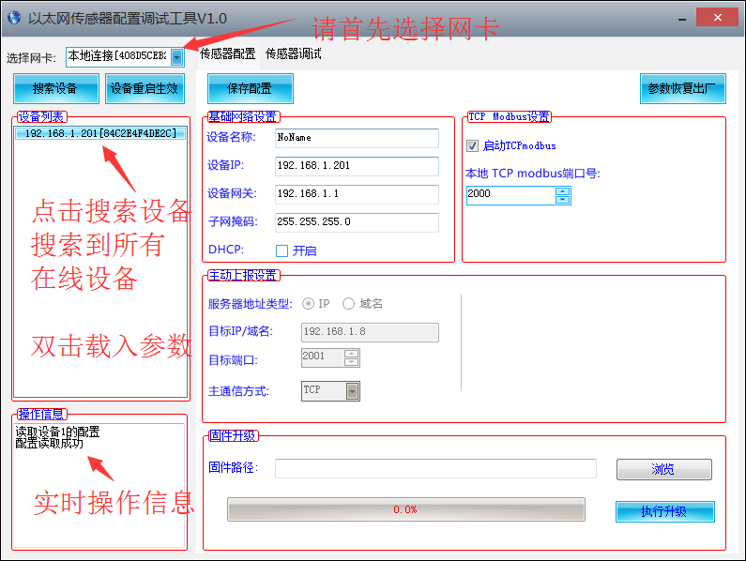
You can modify the specified parameters, after modifying the parameters, click
3.2 The network configuration of the sensor
The basic settings of the equipment mainly include the following aspects:
Basic network settings
Equipment name | Customers use to mark their own equipment name, modify it by themselves, the length is not more than 10 Chinese characters or 20 English.
Device IP | The static IP of the Ethernet sensor itself. Use this IP when DHCP is not checked.
Device gateway | The gateway of the Ethernet sensor itself. Use this gateway when DHCP is not checked.
Subnet Mask | The subnet mask of the Ethernet sensor itself. Use this subnet mask when DHCP is not checked.
DHCP | Automatically search for IP, it will automatically obtain IP, gateway, and subnet mask according to the router in your network.  If DHCP is not enabled in the router, a static IP will be used after 1 minute.
TCPmodbus settings
start up  TCPmodbs | After checking this option, the device works in TCPmodbus slave mode. TCPmodbus and active upload can only choose one
Local TCP | modbus port TCP port number for monitoring.
Proactively report settings
Server address type | can choose to upload to specified IP or specified domain name.  Either IP form or domain name form.
Target IP/domain name | The specified IP or domain name to be uploaded to. The length of the domain name cannot exceed 14 English characters.
Destination port | The designated port to be uploaded to.
Main communication mode | TCP protocol or UDP protocol used for active upload.
3.3 Sensor parameter setting
Some parameters can be set on the sensor debugging page. Note that when setting these parameters, the device must work in TCP modbus mode and cannot work in active upload mode.
TCPmodbus configuration settings
TCPmodbus slave address | The slave address of TCPmodbus can be set, ranging from 0-253, where 254 is the broadcast address.
Protocol type | You can choose the active upload protocol type. 0 means not uploading actively, 1 means uploading actively using the system default protocol, and 2 means uploading actively using other protocols.
3.4 Switch between active upload and TCPmodbus mode
The system works in TCP modbus mode by default. If you need to switch to the active upload mode, please follow the steps below. Pay attention to the sequence of steps not to be disordered, otherwise the configuration will fail.
①Set the reporting protocol to 1 on the sensor debugging page, and modify the reporting interval to the interval you expect.
②On the sensor configuration page, uncheck the option to start TCPmodbus, set the active report setting, and save the configuration.
If you need to switch back to TCPmodbus mode, please follow the steps below, paying attention to the sequence of steps not to be disordered, otherwise the configuration will fail.
①On the sensor configuration page, check the option to start TCPmodbus and save the configuration.
②Set the reporting protocol to 0 on the sensor debugging page.

ⅣCommunication Protocol (TCP modbus)
4.1 TCP modbus basic communication format
TCP Modubs is composed of two parts, consisting of MBAP header and PDU data packet.
The MBAP data header contains the following parts:
Area | Length | Description | Client (Host) | Server (slave)
Transmission flag | 2 bytes | The serial number during MODBUS request and response transmission is generally incremented by 1 for each transmission | Client generation | Copy the value when answering
Agreement sign | 2 bytes | Modbus protocol defaults to 0 | Client generation | Copy the value when answering
length | 2 bytes | The length of the remaining part | Client generation | Copy the value when answering
Unit flag | 1 bytes | Slave flag (slave address) | Client generation | Copy the value when answering
Among them, the PDU data is composed as follows, compared with the Modbus-RTU protocol, the check code is missing.
Function code | Register start address | Register length
1bytes | 2bytes | 2bytes
Slave machine response frame structure:
Function code | Number of valid bytes | First data area | Second data area | Nth data area
1bytes | 2bytes | 2bytes | 2bytes | 2bytes
4.2 Register address
Register address | PLC configuration address | Content Operation | Operation
0002H | 40002 | Dissolved oxygen content (unit: 0.01mg/L | Read only
0100H | 40101 | Device address (0-252) | R/W
0101H | 40102 | Baud rate (2400/4800/9600) | R/W
4.3 Communication protocol example and explanation
4.3.1 Read the dissolved oxygen value of the device address 0x01
Interrogation frame
Transmission flag | Protocol flag | Length
0x00 0x01 | 0x00 0x00 | 0x00,0x06
Unit mark | Function code | Start address | Data length
0x01 | 0x03 | 0x02 | 0x00,0xBD
Response frame (for example, read the dissolved oxygen value is 1.89mg/L)
Transmission flag | Protocol flag | Length
0x00 0x01 | 0x00 0x00 | 0x00,0x05
Unit mark | Function code | Start address | Data length
0x01 | 0x03 | 0x00,0x02 | 0x00,0x01
Dissolved oxygen:
00BD H(hexadecimal)=189=>dissolved oxygen=1.89mg/L
V Proactive Reporting Agreement
5.1 Active reporting method
The device can actively report in the TCP or UDP mode, and the reporting is in the Client mode. The TCP uses the long connection form, and the device has the Keep Alive mechanism. It will actively maintain the connection with the service area and perform unlimited disconnection reconnections.
5.2 Basic composition of the agreement
The basic components of the agreement are as follows:
Frame header (2) + version (1) + device ID (6) + transmission Session (4) + command byte (1) + length (2) + content (n) + checksum (1)
The frame header is 2 bytes, which is fixed as 0xfe 0xdc.
The device version number is 1 byte, which is 0x01 in this protocol.
The device ID is 6 bytes and is fixed inside the factory. Each device has a unique device ID. Customers can use this ID to distinguish different devices.
The transmission session is 4 bytes, designated by the device, and incremented by 1 each time it is sent to identify the transmission sequence of the device.
See below for command byte, length and content.
The checksum is 1 byte. The checksum is not used in this protocol, and it is fixed at 0 here.
5.3 Proactive reporting agreement
The command byte, length, and content of the actively reported command are as follows.
Command byte | length | content
0x03 | 0x30（48） | See the content of the data report below
Data report content:
Data 1 content (4 bytes) | Data 2 content (4 bytes) | .. | Data 12 content (4 bytes)
5.4 Examples of dynamic reporting agreements
The following is the data actively uploaded by a device:
fe dc 01 25 ab 4e a3 25 00 00 00 05 03 00 30 00 00 00 28 00 00 00 00 00 00 00 00 00 00 00 00 00 00 00 00 00 00 00 00 00 00 00 00 00 00 00 00 00 00 00 00 00 00 00 00 00 00 00 00 00 00 00 00 00 00
Among them, fe dc is the fixed frame header, 01-bit version number, the unique id of the device is ab4ea325, the session of this instruction is 00000005, and the length of this data is 0030, which is 48 bytes.
The first set of numbers uploaded is dissolved oxygen 00000028 representing 0.40mg/L, the remaining 11 sets of data are all used for 00000000, and the last 00 is the checksum.

