UWB gateway usage instructions
JX-7001-UWB
Ver1.0


Ver1.0

Directory
Chapter 1 product introduction 2
1.1 product overview 2
1.2 ranging principle 2
1.3 positioning principle 3
1.4 features 4
1.5 product parameters 4
chapter 2 Hardware Connection 4
2.1 product list 4
2.2 product appearance size drawing 5
2.3 product structure diagram 5
chapter 3 product description 6
3.1 instructions for use 6
3.1.1 Address setting 6
3.1.2 the network configuration of the Gateway. 7
3.2 base station layout principle 8
3.2.1 3D positioning 8
3.2.2 One-dimensional positioning 9
3.3 indicator light description 10
chapter 4 use environment 10
4.1 locate Influencing factors 10
4.2 troubleshooting 11

Chapter 1 Product introduction

Product overview
UWB Gateway (hereinafter referred to as the gateway) product is a high-precision indoor positioning product developed by our company. The product uses a brand-new ultra-wideband communication technology. The data is transmitted through extremely narrow pulses below the nanosecond or nanosecond level, which can achieve indoor positioning accuracy at the centimeter level.
The product supports TOF positioning methods and can be applied to indoor scenarios such as factories, power plants, hospitals, warehouses, and pavilions.

Ranging principle
The UWB products developed by our company use the TW-TOF (two-way flight time) method for ranging. That is, each module will generate a timestamp from the start, and the transmitter of module A transmits a pulse signal of the request nature at a certain time on its timestamp, module B receiver receives the signal at a certain time on its timestamp; after the signal is processed in a certain way, module B transmits a signal of a response nature at a certain moment, module A receives this signal at a time on its timestamp. Finally, by calculating the flight time of the pulse signal between the two modules, the flight distance is calculated, as shown in the figure below:
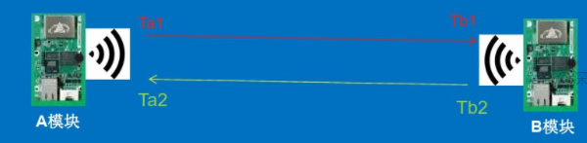

Positioning principle
The principle of UWB positioning is similar to that of satellite navigation and positioning. By arranging 3-4 base stations with known coordinates indoors, the personnel or equipment that needs to be located carry the positioning tag. The tag transmits pulses at a certain frequency and continuously measures with the base station, finally, the positioning coordinates are accurately calculated by a certain algorithm, as shown in the following figure:
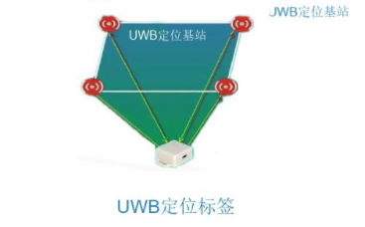

Features
- According to different scenes, one-dimensional, two-dimensional and three-dimensional positioning can be realized.
- Supports TOF positioning
- Supports TCP or UDP protocols
- Support 256 location tags
- Product penetration, low power consumption, accurate positioning, high security
- Supports DHCP to automatically obtain IP addresses
- Support 6 RF bands (3.5GHz to 6.5GHz)

Product parameters
Parameter name | Parameter content
Working voltage | 12-15V DC
Working current | ≤ 200mA
Working temperature | -40~85 ℃
Ethernet Port | Route 1 (WAN port)
UWB antenna | 3.5GHz to 6.5GHz
Tag capacity | 256

Chapter 2 Hardware connection

2.1 Product list
Please check the equipment list before installing the equipment.

Name | Quantity
UWB Gateway | 4 units
Power adapter | 4
Certificate/Warranty Card | 1 serving

2.2 Product appearance and size diagram
The following figure is the appearance and size of the product, as shown in the figure:
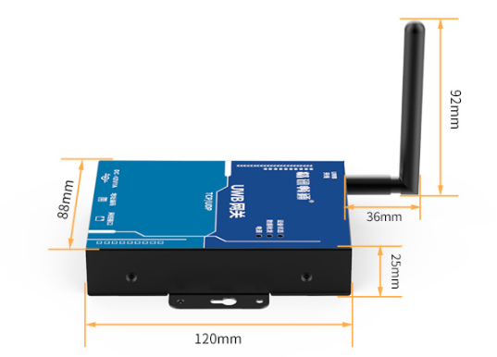

2.3 Product structure diagram
The following figure is a description of the product structure, as shown in the figure:
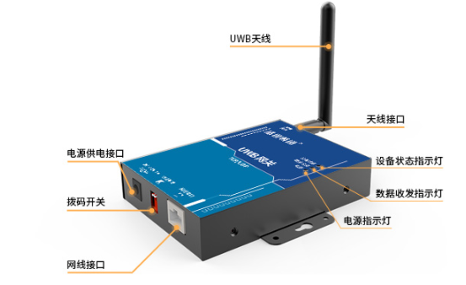

Chapter 3 Product description

3.1 Instructions for use
When networking multiple gateways, in the same personal area network, the Gateway needs to be set to different addresses. The typical number of gateways in a personal area network is four, the server calculates the location of the tag by obtaining the distance between the Gateway and the tag.

3.1.1 Address settings
Set the gateway to different addresses through the two-digit dial switch on the Gateway. After the device is set, the address set by the device is re-powered and powered on. DIP switch combinations are as follows:
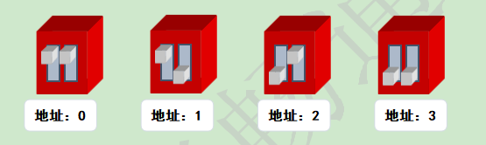

3.1.2 The network configuration of the Gateway.
After the device has set the address, the network parameters of the device need to be set. First, the device is powered on and the network cable is connected to the Gateway (the gateway needs to be under the same switch as the computer), open the network configuration software provided by the company to configure the network parameters. The configuration process is as follows:
(1) click "Search for Devices", and the device list will show the modules in the subnet;
(2) select the gateway in the device list and modify the parameters on the left. It is recommended to turn on DHCP here to allow the gateway to automatically obtain the IP address. If necessary, you can also turn off DHCP and manually fill in the device IP, enter the subnet mask and Gateway parameters, and then click Configure Device Parameters to take effect;
(3) after the configuration is completed, the module will restart. Wait a while, click Search Device to find the module and view the configuration results.
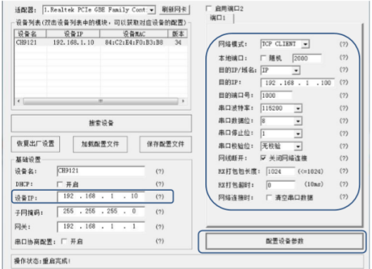
(4) after the module restarts, click "Search Device" again, and select the gateway in the list.
(5) set the network mode for TCP CLIENT, the destination IP, the destination port is set to the server's IP address and port, the serial port baud rate is set to 115200, the serial data bit is 8, the serial port stop bit is 1, by default, other parameters are required. After writing, click Configure Device Parameters. The module automatically restarts and the parameter settings take effect. The Gateway automatically connects to the configured server IP address.

3.2 Base station layout principle

3.2.1 3D positioning
Accurate three-dimensional positioning A positioning base station is installed every 10-30 meters. Yes, there are four base stations that can receive the pulse from the tag at any time, as shown in the following figure:
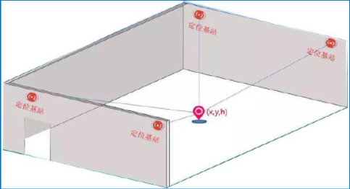

3.2.2 One-dimensional positioning
One-dimensional positioning is a ranging application, suitable for tunnels and mines with low accuracy, with an accuracy of about 0.3 meters, as shown in the following figure:
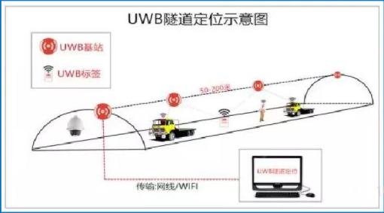

3.3 Indicator light description
There are three LED indicators on the Gateway, namely, power indicator, data sending and receiving indication and device initialization indicator.
- Power indicator: This light is on when the Gateway Power is working normally.
- Data Transmission and Receiving Indicator: This light flashes when the Gateway interacts with the tag.
- Device initialization indicator: When the device is in initialization, the light flashes, and after the device initialization is completed, the light goes out.

Chapter 4 Use environment

4.1 Locate Influencing factors
The influence factors of UWB positioning are mainly divided into the following situations:
- Solid Wall: A glimpse of the solid wall will make the UWB signal attenuation 60-70% positioning accuracy, the error will rise more than 30cm, two or more solid wall blocking will lead to the inability to locate.
- Steel plate: The absorption of pulse signal by steel is very serious, which will lead to the inability to locate.
- Glass: Glass shielding has little effect on positioning accuracy.
- Wood board or cardboard: board or cardboard with a thickness of less than 10cm has little effect on positioning accuracy.
- Telepole or tree: When a telepole or written cover, it is necessary to see the distance between them from the base station or tag, and whether the relative distance between the base station and the tag is relatively small. For example, the distance between the base station and the positioning tag is 50 meters, and the utility pole or tree is exactly in the middle of the two. This occlusion has little effect; if the distance from the base station or tag is less than 1 meter, will have a big impact.

4.2 Troubleshooting
(1) The power indicator does not light up
  - The power supply is not plugged in: please check it back in again.
  - Power supply damage: Please contact after-sales to replace the power supply.
(2) The network cable device cannot be connected to the network.
  - Network Abnormal: First, test whether devices in the same LAN as the gateway can connect to the network.
  - Network cable damage: replace network cable
  - Poor connection of the network cable port: check carefully to make sure that the plug is normal.
  - Switch/router does not turn on DHCP: Enable DHCP or use static IP.
(3) Device initialization indicator
  - Device UWB module fault.
(4) The gateway cannot connect to the server.
  - IP address or port number error: Please check and fill in again.
(5) Network error: see above, the network cable device cannot be connected

