Explosion-proof
Combustible Gas Sensor
Operation
Instruction
JXBS-4001-LEL__{Type} ₄₈₅
Ver1.0


INSTRUCTION MANUAL

CHAPTER 1 Product Introduction

Product Overview
The explosion-proof combustible gas sensor is specially developed for some harsh environments. Cast aluminum explosion-proof shell, the probe is placed in a special metal probe bin, and the electrical part is isolated from the probe.
Combustible gas sensor adopts professional combustible gas concentration sensor probe as the core detection device; It has the characteristics of wide measuring range, high precision, good linearity, good universality, convenient use, easy installation, long transmission distance and moderate price.

Functional Characteristics
This product adopts high-sensitivity gas detection probe with stable signal, high precision and long quick response life. It has the characteristics of wide measuring range, good linearity, convenient use, convenient installation and long transmission distance. Note that the sensor is used for air detection, and the customer should test it in the application environment to ensure that the sensor meets the requirements.

Product Parameter
parameter | Technical indicators
LEL  measurement range | 0-100%LEL
Measurement method | Catalytic combustion type
Response time | Less than 20 seconds
Measurement accuracy | 3%F.s
Interface form | Quantity (RS485)
Power supply | 12V-24VDC
Consume too much electricity | <1W
Operating temperature | -30-50℃(-20-40℃ continuous)
Working humidity | 0-100%RH(15-95%RH)
Environment outline | dimension explosive-proof

gas | lower explosive limit | LEL  concentr ation | gas | lower explos ive limit
metha ne | 5.0% | 100% | methane | 5.0%
propa  ne | 2.1% | 100% | propane | 2.1%
* Hydr  ogen | 4.1% | 100% | * Hydrogen | 4.1%

* This product does not have hydrogen explosion lower limit detection by default.

CHAPTER 2 Hardware Connection

Equipment Pre-installation Inspection
Please check the equipment list before installing the equipment:
name | quantity
Explosion-proof  sensor | 1 set
12V waterproof  power supply | 1 set  (optional)
USB to 485  device | 1 set  (optional)
Warranty  card/certificate | 1 copy

Interface Description
Wide voltage power input can be 12-24V. 85 Pay attention to the fact that the A/B lines can't be reversed when connecting the signal lines, and the addresses of multiple devices on the bus can't conflict.

 | Line color | explain
Pow er S  uppl y | brown | Positive power supply  (12-24VDC)
Pow er S  uppl y | black | Negative power supply
com mun icati  on | Yellow (grey)  color | 485-A
com mun icati  on | blue | 485-B
By default, 0.85-meter-long wire rod is provided at the factory, and customers can extend the wire rod or connect the wires in sequence as needed.

Installation Instructions
The explosion-proof sensor is wall-mounted and can be fixed by three 8.5MM fixing holes. Customers can fix it with expansion screws or bolts. The size and position of fixing holes are as follows:
Please ensure the installation direction when installing, and the gas inlet of the gas bin is installed vertically downward.

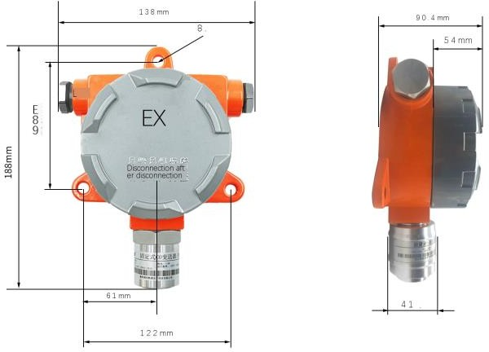

Figure 1. Dimensions of non-digital display acousto-optic sensor

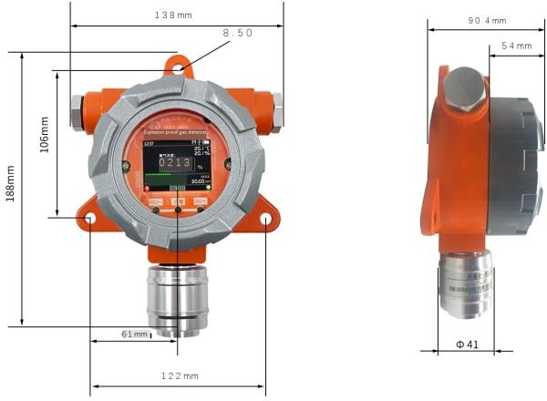

Figure 2. Digital display sensor size

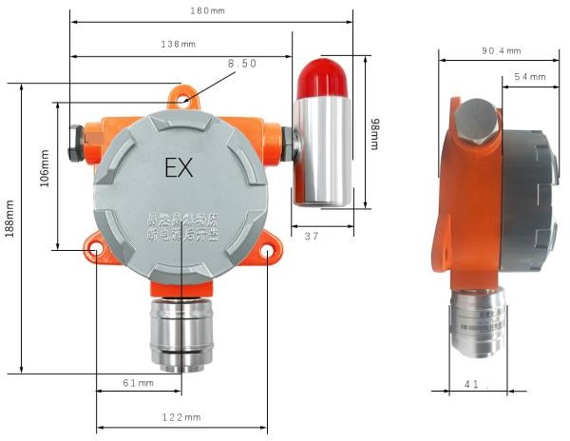

Figure 3. Dimensions of acousto-optic sensor
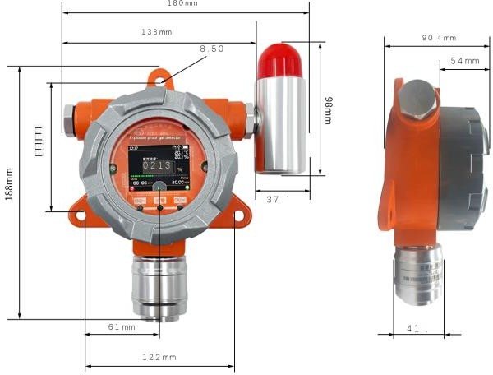

Figure 4. Dimensions of acousto-optic digital display sensor

CHAPTER 3 Configure Software Installation and Use
Our company provides supporting "sensor monitoring software", which can easily read the parameters of the sensor by computer and flexibly modify the device ID and address of the sensor.

Sensor Access to Computer
After the sensor is properly connected to the computer through USB 485 and supplied with power, you can see the correct COM port in the computer (see the COM port in "My
Computer-Properties-Device Manager-Port").
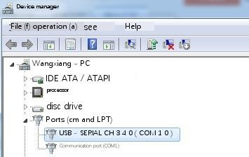
As shown in the figure above, your serial port number is COM10 at this time. Please remember this serial port, which needs to be filled in the sensor monitoring software.
If the COM port is not found in the device manager, it means that you have not inserted USB 485 or installed the driver correctly. Please contact the technician for help.

Use of Sensor Monitoring Software
The software interface is shown in the figure:

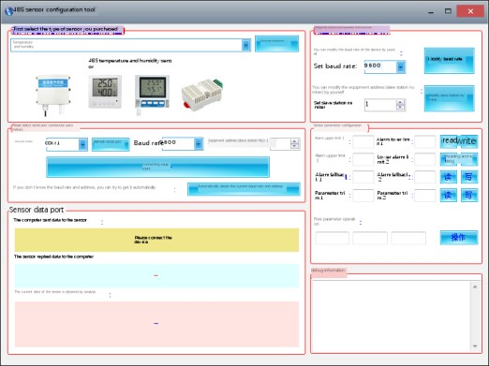
After opening the software, first select the "sensor type" at the top of the software, then get the serial port number and select the correct serial port according to the method in Section 3.1, and then click "Automatically get the current baud rate and address" to automatically detect all devices and baud rates on the current 485 bus. Please note,It is necessary to ensure that there is only one sensor on the 485 bus when using software for automatic acquisition. Then click "Connect Device" to get the sensor data information in real time.

Modify Baud Rate and Device Address
When the "device connection" is disconnected, click "Modify baud rate and modify slave station number" in "Configure sensor communication parameters" to complete relevant settings. Please pay attention to restart the device after setting, and then

"Automatically get the current baud rate and address" to find that the address and baud rate have been changed to the address and baud rate you need.

CHAPTER 4 Communication Protocol

Basic Communication Parameters
parameter | content
encode | 8-bit binary
data bit | 8 bits
parity | without
Stop bit | 1 bit
Error  calibration | CRC redundant cyclic code
Baud rate | 200 bps/4800 bps/9600bps can be set, and  the factory default is 9600 bps.

Data Frame Format Definition
Modbus-RTU communication protocol is adopted in the following format:
Initial structure > =4 bytes time Address code =1 byte
Function code =1 byte Area =N bytes
Error check =16-bit CRC code End structure > =4 bytes time
Address code: the address of the transmitter, unique in the communication network (factory default 0x01).
Function code: the instruction from the host indicates that this transmitter only uses function code 0x03 (reading meory data).
Data area: the data area is the specific communication data area, and note that the high byte of 16bits data comes first.
CRC code: Two-byte check code. Inquiry frame
address code | function code | register start address | Register length | check code low post | check  code high position
1 byte | 1 byte | 2 bytes | 2 bytes | 1 byte | 1 byte
Response frame

address code | function code | Effective number of bytes | Data zone 1 | second data field | Nth data field
1 byte | 1 byte | 1 byte | 2 bytes | 2 bytes | 2 bytes

Register Address

Register address | PLC  configu ration address | content | operate
0006H | 40007 | Combustible gas  concentration (0.1ppm) | read  only
0100H | 40101 | Equipment address (0-252) | read and  write
0101H | 40102 | Baud rate (2400/4800/9600) | read  and write

Examples and Explanations of Communication protocols

Read the LEL Value of Device Address 0x01
Inquiry frame
addres s code | functi on code | start address | Data length | Low bit check code | High bit check code
0x01 | 0x03 | 0x00,0x06 | 0x00,0x01 | 0x64 | 0x0B
Response frame
addres s code | functio n code | Effective number of bytes | LEL  value | check code low post | check code high position
0x01 | 0x03 | 0x02 | 0x00  0xBD | 0x78 | 0x35
LEL：
00BD H (hexadecimal) =189=>LEL=18.9%

Conversion Between ppm of LEL Measurement Unit and ug/m³
According to the calculation, we can get the conversion relationship, which is only valid for LEL:
1ppm = 46/22.4=2.05mg/m³=2050ug/m³
1ppb = 46/22.4=2.05ug/m³
The above calculations are all aimed at the standard atmospheric pressure.

